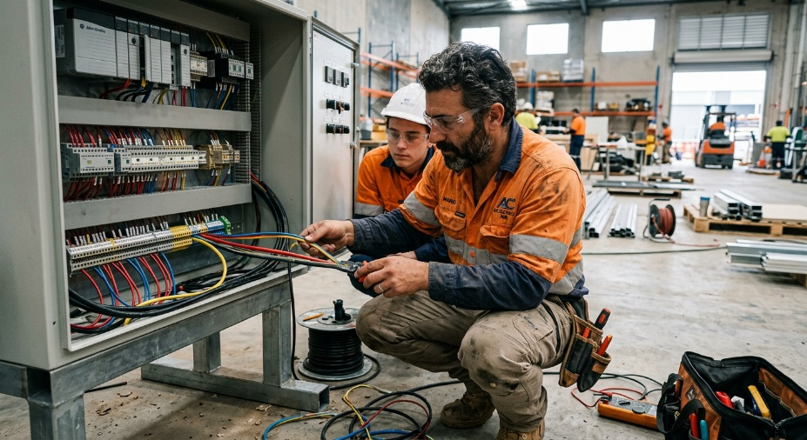
Learner #2: Leo Moretti

About Me: | Leo is a 38-year-old A-Grade electrician based in Adelaide, where he runs Moretti Electrical Services from his home in the western suburbs. He has been on the tools since leaving school and recently started picking up sub-contracting work on industrial control cabinet builds for Global-Tech, alongside his bread-and-butter domestic and small commercial work. Leo lives with his partner and two primary-school-aged kids, and the family schedule, school drop-offs, and footy commitments tend to dictate when his evenings are actually his own.
Professional and Learning Experience: | Leo holds a Certificate III in Electrotechnology Electrician (2008), a current A-Grade Electrician's Licence, and a current Working at Heights and EWP Yellow Card. He has fifteen-plus years of practical experience covering domestic and commercial wiring, switchboard upgrades, fault diagnosis, and PLC hardware installation, with deep working knowledge of AS/NZS 3000 and AS/NZS 3008. Leo has been mentoring apprentices on-site for years, including a current second-year apprentice (Jake) who is progressing well under his supervision through the UEELW0033 termination unit. He is enrolled in the Cert IV in Training and Assessment to formalise the coaching he is already doing on the job.
Career/Training Goals: | Leo is looking to scale back the long days on the tools and move into a part-time TAFE delivery role, ideally teaching apprentices the practical side of cable termination, control circuits, and isolation procedures. He is keen to stay connected to industry through his sub-contracting work but wants the Cert IV behind him so he can pick up sessional teaching shifts that fit around his family.
Working Style and Preferences: | Leo is at his absolute best when he is in the workshop or on site with a tool in hand. He runs his apprentice toolbox talks well, demonstrates cleanly, and is patient at the bench. Where things tend to come unstuck for Leo is anywhere there is a desk, a keyboard, and a deadline that is not also a customer waiting at his door. He is meticulous about his physical wiring (his project manager describes it as “some of the best I've seen”) but his quoting is often a few days behind, his apprentice records are written up in retrospect from memory, and his bookkeeper has a standing reminder to chase him for receipts at the end of every month.  Leo has mentioned that long blocks of reading are a slog for him, and he tends to skip to the diagrams in any technical manual. He has shared in conversation that schoolwork was always a struggle, that he was “the one the teacher gave up on,” and that he relies heavily on his partner to proofread anything he sends to a customer in writing. He works best in short, active bursts and finds it genuinely difficult to sit still through long meetings or written training sessions; he tends to fidget, take phone calls, or wander out of the room mid-session unless there is something practical to do. Leo has an iPad and a reasonably new laptop, both of which he uses confidently for SimPRO quoting, AutoCAD viewing, and email, so his digital fluency is fine, his confidence in writing on a blank page is a different story.
Additional Information: | Leo is an active member of his local junior football club, where he runs the under-10s training on Tuesday and Thursday evenings. He has mentioned recently that he has been considering an adult assessment for some long-standing issues with attention and reading that he has worked around his whole career; he is open about it but has not pursued anything formal yet. His preferred way to learn anything new is to “watch someone do it, then have a go,” and he tends to retain practical demonstrations far better than written content.

